**Zack Pelka**

**How to change the “hostname” in Kali Linux**

|  |  |
| --- | --- |
| Prepared By: | Zachary Pelka |
| Document Version: | 1 |
| Last Updated On: | 2MAY2021 |
| Document Classification: | Public Domain |

The information in the document may contain proprietary and confidential information that is intended for the employees of ZP Enterprises only. If you are not an employee of ZP Enterprises, you are hereby notified that any disclosure, copying, distribution, retention or use of the contents of this information is prohibited in an altered form. This is for public use without modification.

## **Purpose**

Every node of a network needs to have a unique name and IP address. This will help change the name of a Kali / Debian named machine.

By default, my hostname (computer name) is kali as you see in the picture.

[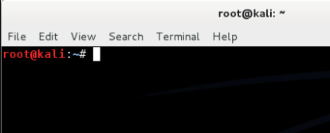](https://phoenixinfosec.files.wordpress.com/2014/06/capture.png)

Steps :

1. Open a Terminal (Ctrl+Alt+t) and enter the command “**hostname**” (without the quotes). This command shows the hostname of our machine.

[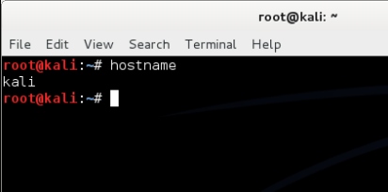](https://phoenixinfosec.files.wordpress.com/2014/06/capture1.png)

2. For changing the host name, we use the same command “hostname” followed by your new desired hostname

*command usage* :

**hostname** *new_host_name*

[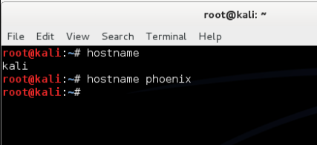](https://phoenixinfosec.files.wordpress.com/2014/06/capture2.png)

To view the change in hostname, open a new terminal

[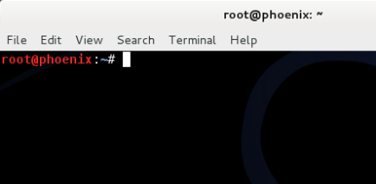](https://phoenixinfosec.files.wordpress.com/2014/06/capture3.png)

The above command is only applied on specific session, so when you start the hostname service or restart your computer, the hostname will return to the old one (kali).

3. So, in order to make the hostname change permanent, we should edit the file named located in  **/etc/hostname**(this is where the hostnames are stored).

Use the editor command **pico** to edit that file. You can use any other editor command as you prefer.

[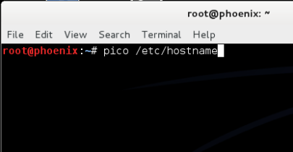](https://phoenixinfosec.files.wordpress.com/2014/06/capture4.png)

The file opens in the editor for editing.

[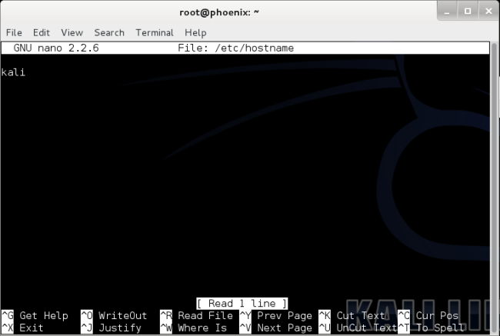](https://phoenixinfosec.files.wordpress.com/2014/06/capture5.png)

Delete the entry “kali” (in my machine) and enter your desired hostname.

[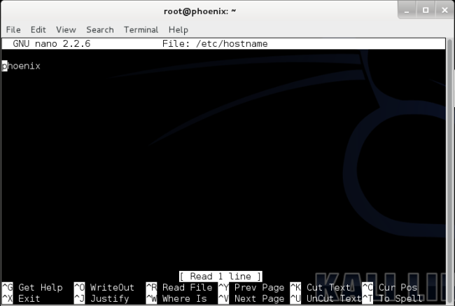](https://phoenixinfosec.files.wordpress.com/2014/06/capture6.png)

Press ***Ctrl+O***and hit enter to save and press ***Ctrl+X*** to exit.

4. To check whether your hostname have changed or not, you can use the command “***service hostname start***” which restarts the service “hostname” or simply ***reboot*** your kali machine.

5. Now you have your new desired hostname permanent.

**Revision History**

|  |  |  |  |
| --- | --- | --- | --- |
| **Version** | **Date** | **By** | **Changes** |
| **1.0** | 2MAY2021 | Zachary Pelka | Initial Draft |
|  |  |  |  |
|  |  |  |  |